5g 6g lap exp
Exp 1
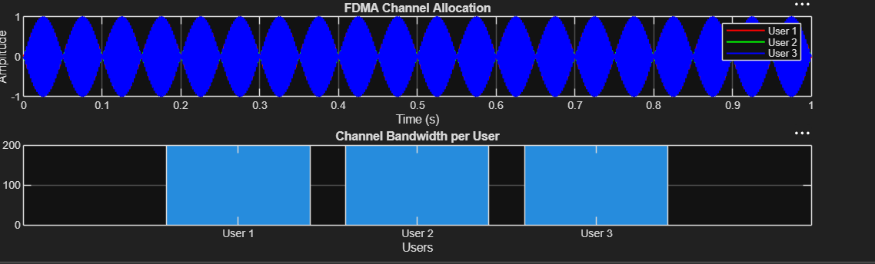
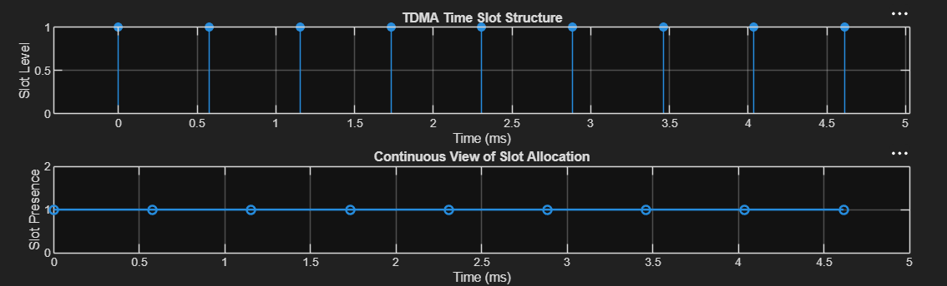
Exp2

Exp3


